 MROQC Lung Hypofractionation Consensus Practice Guidelines

Introduction
The use of hypofractionation for patients being treated for lung cancer is common, but widely accepted guidelines on fractionation schemes and goals are sparse. To harmonize practice and support standardized quality across the state of Michigan, we have proposed consensus guidelines developed by members of the MROQC Lung Working Group. These guidelines will evolve as MROQC learns more and national data matures in this area.

Compliance with consensus recommendations noted as “Phase 1” will be evaluated as part of the consortium wide performance measure for 2026.

MROQC Consensus Recommendations
Common Indications for Hypofractionation
There are no published guidelines on patient selection for hypofractionation. The current stance of the MROQC Lung Working Group is that hypofractionation can be done at the discretion of the treating radiation oncologist. In broad terms, candidates for hypofractionation may be Stage I or II patients for whom stereotactic body radiation therapy (SBRT, 1-5 fractions) would be preferred, but such treatment may not be selected due to tumor size or location. Further, some Stage III patients that are not candidates for chemotherapy could be candidates for hypofractionation. Hypofractionation may offer a biological advantage for tumor control over conventional fractionation and an improved safety proﬁle over standard SBRT fractionations.

Fractionation Scheme
The use of 8, 10, or 15 fractions is common for hypofractionation as an alternative to SBRT in Stage I and II patients, and all regimens have some published evidence. These schemes represent the majority of hypofractionation utilization in MROQC in 2024-2025.
Phase I recommendation: Usage of 8, 10, or 15 fractions when using hypofractionation as an SBRT alternative for Stage I and II patients, based on published data and consistency of practice across existing MROQC facilities employing this technique.
For facilities choosing a total of 16-20 fractions, such as may be utilized in Stage III patients, the dosimetric guidelines should follow the MROQC recommendations for 15 fractions.

Treatment Planning Recommendations
Consistent with national clinical trial guidance from NRG Oncology, planning priorities are recommended to meet
ﬁrst meet critical OAR goals, then PTV coverage, then secondary OAR goals.

Treatment Planning Priority Recommendations
Planning Priority | Instructions
1 | Respect priority 1 OAR objectives
2 | Achieve PTV coverage and maintain dose conformity. In cases of overlap with Priority 3 OAR criteria, it is recommended to meet minimum target coverage and minimize hotspots  in OAR overlap areas.
3 | Attempt to meet Priority 3 OAR goals

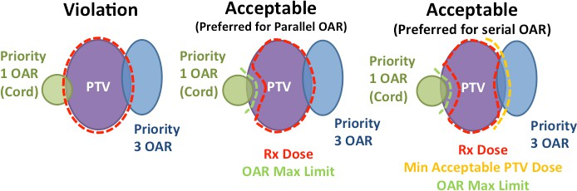
Graphical representation of planning tradeoffs in areas of overlap from NRG Oncology template

Dosimetric Goals
MROQC institutions using hypofractionation for lung in clinical practice submitted their dosimetric guidelines to help develop consensus recommendations for dosimetric goals for the consortium. Based on these submissions, discussion within the Lung Working Group members and leadership, and in consultation with NRG Oncology protocols and templates, the following dosimetric goals are recommended:

Planning Priority | Target | Dosimetric Parameter | 8 Fx Goal [cGy or %] | 10 Fx Goal [cGy or %] | 15 Fx Goal [cGy or %] | Reference EQD2Gy  (𝜶𝜶/𝜷𝜷 = 10)
NA | PTV | Common Prescription  Doses [cGy] | 6000 | 5000-6500 | 6000 | NA
2 |  | Minimum Coverage [cGy] | 4580 | 4850 | 5320 | 6000
2 |  | D95%[%] | 100% | 100% | 100% | NA
Planning Priority | OAR | Dosimetric Parameter | 8 Fx Goal [cGy or %] | 10 Fx Goal [cGy or %] | 15 Fx Goal [cGy or %] | Reference EQD2Gy  (𝜶𝜶/𝜷𝜷 = 3)
1 | Spinal Cord* | D0.1cc[cGy] | 3230 | 3500 | 4010 | 4550
1 | Brachial Plexus* | D0.1cc[cGy] | 4000 | 4350 | 5030 | 6395
1 | Esophagus* | D0.1cc[cGy] | 4130 | 4500 | 5210 | 6750
1 | Trachea/Bronchus | D0.1cc[cGy] | 4760 | 5200 | 6060 | 8530
1 | Heart | D0.1cc[cGy] | 4760 | 5200 | 6060 | 8530
3 | Lungs - GTV | Mean[cGy] & V33%[%] | ALARA | ALARA | ALARA | NA
* Phase 1 Recommendation

