Overview of BCBSM

PERFORMANCE REWARDS

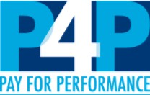

- CQI Funding
  - Participation Payment
  - Coordinating Center Funding
  - Rewarding Improvement
    - Pay for Performance
    - Value Based Reimbursement


Coordinating Center

- Physician leadership
- Quality improvement expertise
- Quarterly conference meetings
- Technical infrastructure
- Analytical tools
- Statistical expertise
- Software development


Participating Entities
- Technical infrastructure
- Data abstraction
- Pay-for-performance opportunities, including Value Based Reimbursement



Participation Payment
$33 Million in 2015
Data Abstraction
BCBSM/BCN Funds 80% of these costs, hospital participants are responsible for the other 20%

Coordinating Center Funding
$20.7 Million in 2015
Quality
Initiative Infrastructure to advance the QI agenda with participants
Quality
Initiative
Leadership

Pay for Performance Incentives
$63.3 Million in 2015
Rewarding hospital
contributions to CQI related
quality improvement efforts

Funding Support for Hospitals Participating in CQIs
Note: Funding support is defined by each individual hospital’s participation agreement with BCBSM and may vary from what is shown below.

Participation Payment
(also known as Full-Time Equivalent (FTE) payment)
- Annual payment to support data abstraction efforts
  - Intended to cover a portion of costs for BCBSM, BCN, government, and uninsured cases (projected to be approximately 80% of case total)
  - Based on a fully loaded RN salary of $96,070
- Payment is based on volume and determined by each individual CQI’s reimbursement model (e.g. one FTE per XXX number of cases)
  - First year’s payment is based on the volume supplied by the hospital on the application for participation and made in the first quarter
  - Subsequent year’s payments are based on the actual volume as supplied to BCBSM by the CQI coordinating center and made in June
Pay-for-Performance Incentive
(also known as P4P)
- Each CQI coordinating center develops a performance index and scores each hospital participant
- Payment is made in July and tied to the score received based on the previous year’s
performance (e.g. 2017 P4P reimbursement will be dispersed in July 2018)
- A hospital can earn up to 40% of their P4P payment as a result of their participation depending on how many CQIs they participate in


Hospital (P4P)
- Component of the BCBSM Pay-
for-Performance Program
- Incentives based on participation and performance in quality and outcome measures
- Measures collaborative-wide or hospital level performance
Physician (VBR)
- Component of BCBSM
Specialist Value-Based
Reimbursement Program
- Incentive based on participation and performance in quality and outcomes measures
- Measures collaborative wide or physician practice level performance

Overview
- Hospitals are eligible to earn up to 40% of the P4P program incentive by
participating in up to ten CQIs (BCBSM and MHA Keystone)
- Each CQI Coordinating Centers establishes Performance Index Scorecard
  - Measured on both participation and performance
- Newer CQIs have more participation measures, but the scorecards transition to greater weight on performance as the CQI becomes more established
  - BCBSM receives overall CQI score from coordinating center (no site specific details)
- Hospitals participating in more than ten CQIs will be scored on ten best
individual CQI index scores, with preference given to BCBSM-sponsored CQIs
- Those hospitals not eligible for ten CQIs will have remaining incentive distributed equally to other program measures

The Performance Index
- Program measures and corresponding weights tied to each individual CQI are referred to as the hospital’s CQI Performance Index scorecard
  - Developed and distributed by the corresponding CQI coordinating center
  - Some measures are related to program participation and engagement, such as meeting attendance and timeliness of the data submission
  - Other measures are performance-based related to quality and clinical process improvement and outcomes, such as reduction morbidity or surgical complications
  - As a CQI matures, the percentage attributed to performance increases and the percentage attributed to participation decreases
  - The measures in each CQI index are subject to change annually

- A hospital’s P4P score for each CQI is determined by its performance on specific measures within the CQI Performance Index scorecard
- BCBSM will combine CQI scores for hospitals participating in multiple CQIs into a single, overall score
- Hospitals eligible for, but voluntarily electing not to participate in a “required” CQI, will forfeit the ability to earn 4% of the P4P incentive for that CQI

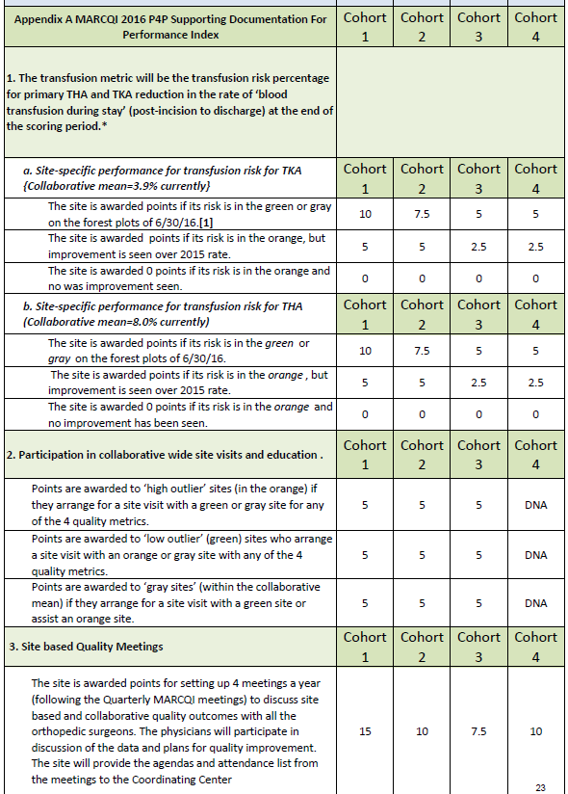
Example of the Performance Index

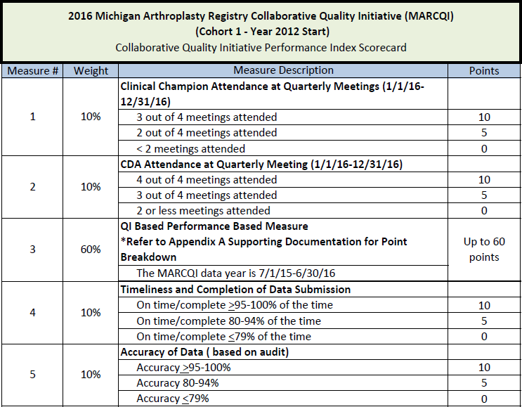

(Note: CDA is a clinical data abstractor)

8

