CDA Database Resource Guide

Contents

Signing into the database 3
MROQC – Level 1 & Level 2 password criteria………………………………………………………………………………………….5
Using the help icon……………………………………………………………………………………………………………………………….…7
Enrolling an eligible patient 8
Adding an ineligible patient 9
Entering data on an enrolled patient 10
Review & edit submitted data 12
Patient decides to no longer complete surveys 13
Survey not completed by patient or physician 14
Excluding Forms…………………………………………………………………………………………………………………………………… 15
Patient has completed treatment and f/u 16
Changing/Editing forms when patient’s status is “Complete” 17
Terminating a patient (SE2 Form) 18

Signing into the database
- From the “members tab” on the MROQC website https://mroqc.org/ , you can access the breast & lung database or the bone mets database.
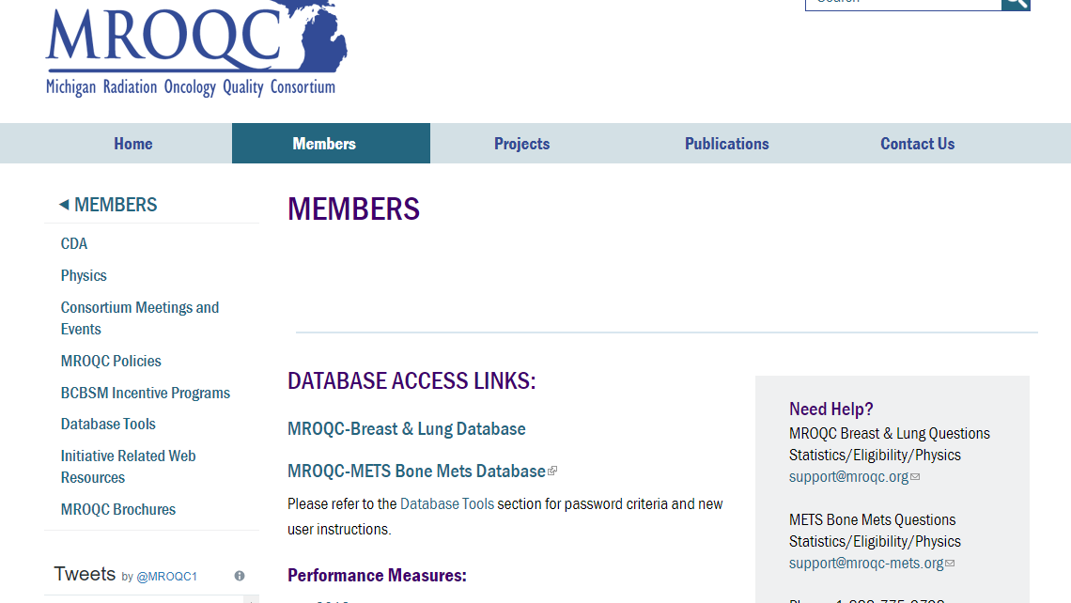

- After selecting the database link, you’ll be prompted to enter your level one (VPN) login: Enter your level one username and password and select Log On. Do not copy and paste your username or password.
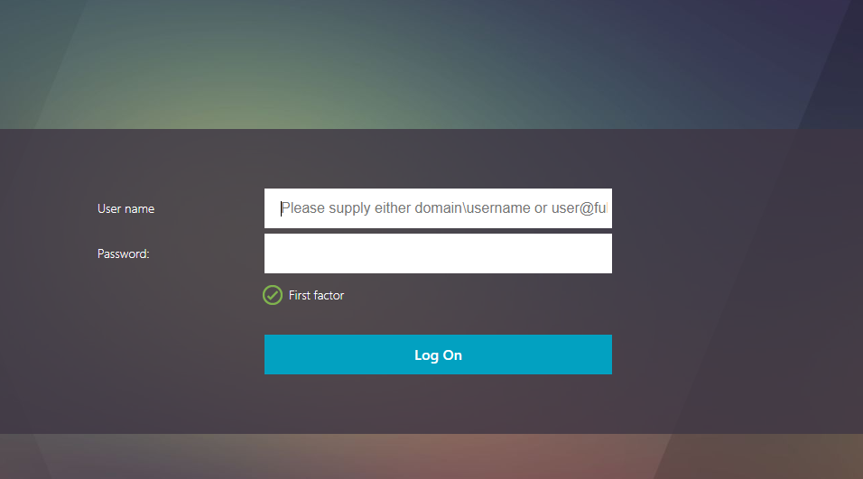

- MROQC (level 2) login: Enter your username and your MROQC (level 2) password and select Login.
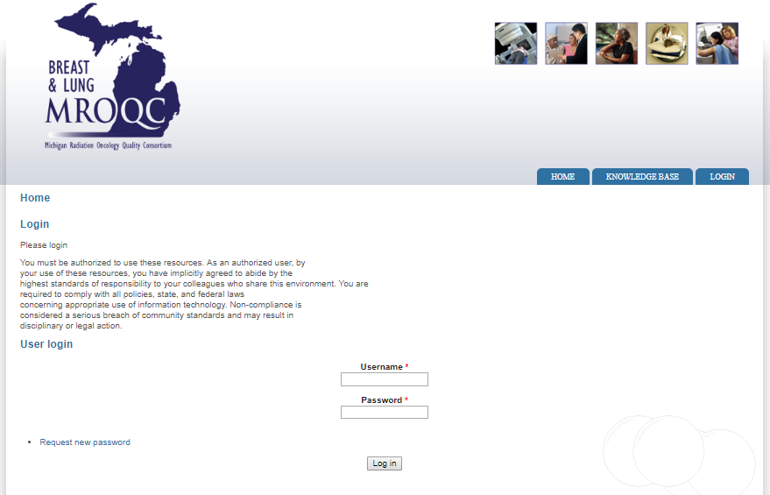

- Next, you will be prompted to enter your token Passcode/number. Select “enter passcode” and enter the 6-digit number displayed on your DUO token. Select Login.
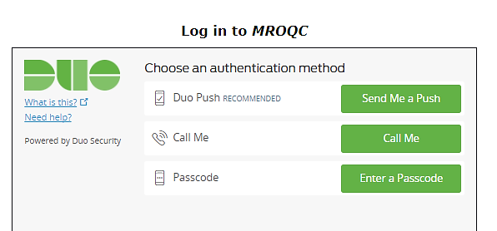

MROQC– Level 1 & Level 2 Password Criteria
When changing your Password please verify your “new” password meets ALL of the following criteria:
Level 1 and Level 2 Password Criteria:
- Password must be at least 10 characters in length
- Password must have at least one uppercase letter
- Password must have at least one lowercase letter
- Password must have at least 2 numbers
- Password must have at least 2 special characters
- Password cannot contain your name
- Password must be different than your past 5 passwords

Level 2 - MROQC or METS Database Login:
- Breast and Lung database has BLUE text
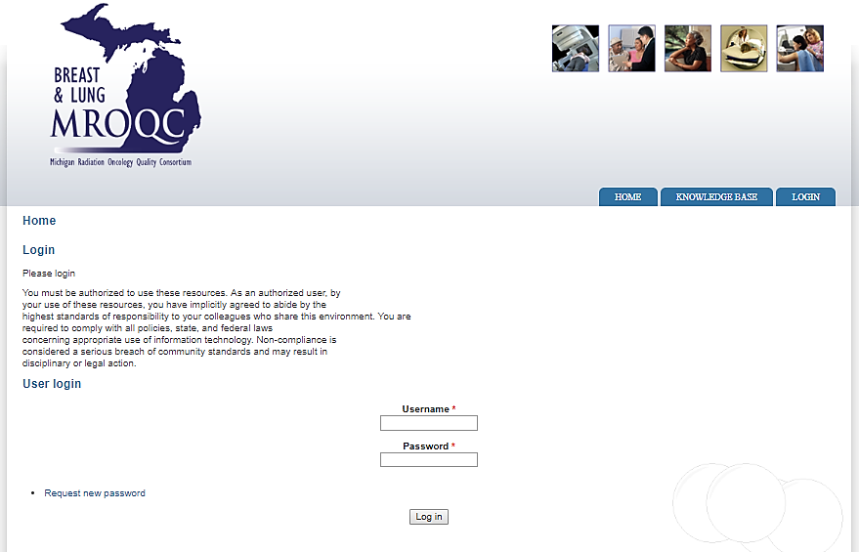

- Please refrain from logging in after 3 failed attempts and submit a support ticket to:
- MROQC (Breast & Lung) Database, please email support@mroqc.org

If you receive the following error message(s):
- The new password you selected does not meet the required password criteria. Please review the above criteria and try again.

- Please verify you have entered your username correctly. If your username has been entered correctly, please contact support.

Important Information
- Please refrain from logging in after three failed attempts and contact support. Additional attempts can result in your account being locked for 24 hours.
- Users that are blocked from the database may need to wait up to 24hrs from their last login attempt before the block is lifted.
- Anyone entering data into the MROQC or METS database MUST enter data using their own account. Please contact support to request “new user” access.
- It is imperative that we actively guard the integrity of our data within the MROQC & METS databases. If you have a change in MROQC personnel at your site, please notify the MROQC Coordinating Center and attempt to retrieve the provided DUO token.

Using the help icon
To submit questions to the MROQC Coordinating Center while working in the database, users may select the green help icon located at the lower right-hand corner of any screen. Questions are emailed to the coordinating center and are answered in the order they are received.
Questions can also be emailed directly to support@mroqc.org

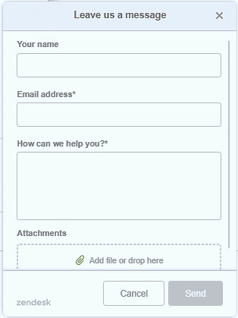
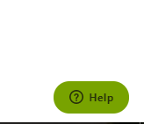

Enrolling an eligible patient

- From the main site page, select the “add new subject” option listed under the hospital menu
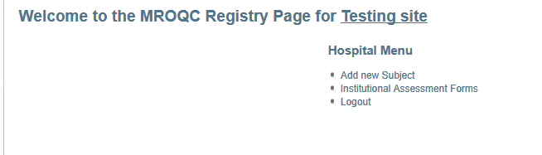
Select to add both eligible and ineligible patients
- Next, the create subject page will display (Enrollment form SE1). Enter patient information following the guidelines in the SE1 data dictionary. Once saved, the patient is enrolled in MROQC.
Please Note
  - Once the form is saved; the patient’s cancer type cannot be changed in the breast and lung database.
  - Active should be the status of all eligible patients.
  - Do not use Legacy status deceased and pending
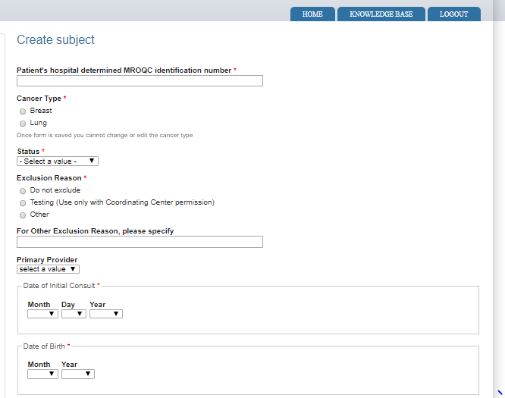
  - An exclusion reason must be selected to save the enrollment form
Once the form is saved the patient cancer type cannot be changed in the breast and lung database
When enrolling an eligible breast or lung patient, “do not exclude” must be checked to save/submit form

Adding an ineligible patient
- From the main site page, select the “add new subject” option listed under the hospital menu
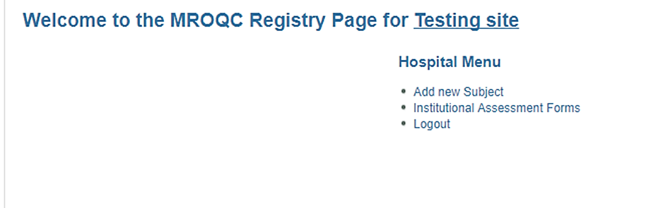
Select to add both eligible and ineligible patients
- The create subject page will display (enrollment form SE1). All required fields (red asterisk) must be entered for ineligible bone mets patients (See SE1 data dictionary for data element information). Once saved, the patient is recorded as ineligible in the database.
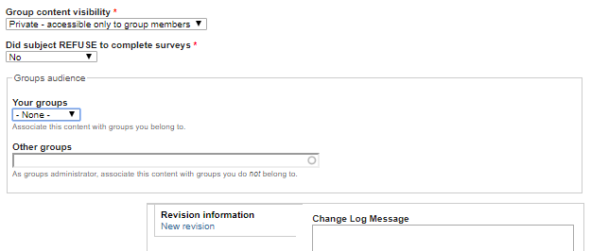
  - Did the subject refuse to complete surveys: this question should be marked as “no” for not eligible patients.

Entering data on an enrolled patient

- From the welcome page, select a patient by their hospital ID number or MROQC ID number.

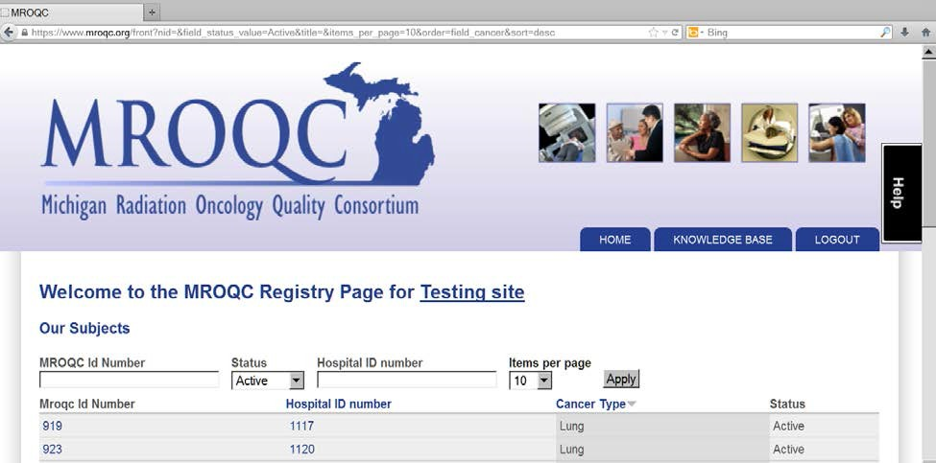

- Once a patient is selected, their MROQC profile will display. By default, the view tab displays the patient’s enrollment information (SE1). Select the enter data tab to enter survey data.

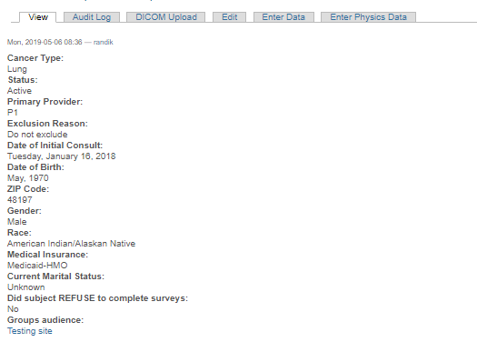

- After selecting the enter data tab, surveys for the patient will display. To enter data, select create survey under the desired form. Once selected, the survey will display.
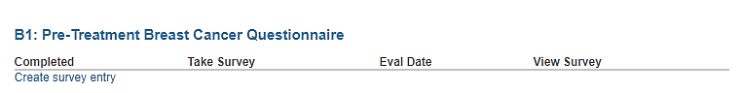

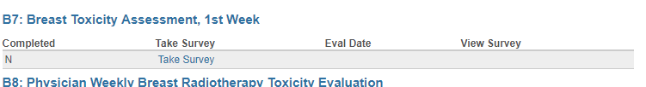
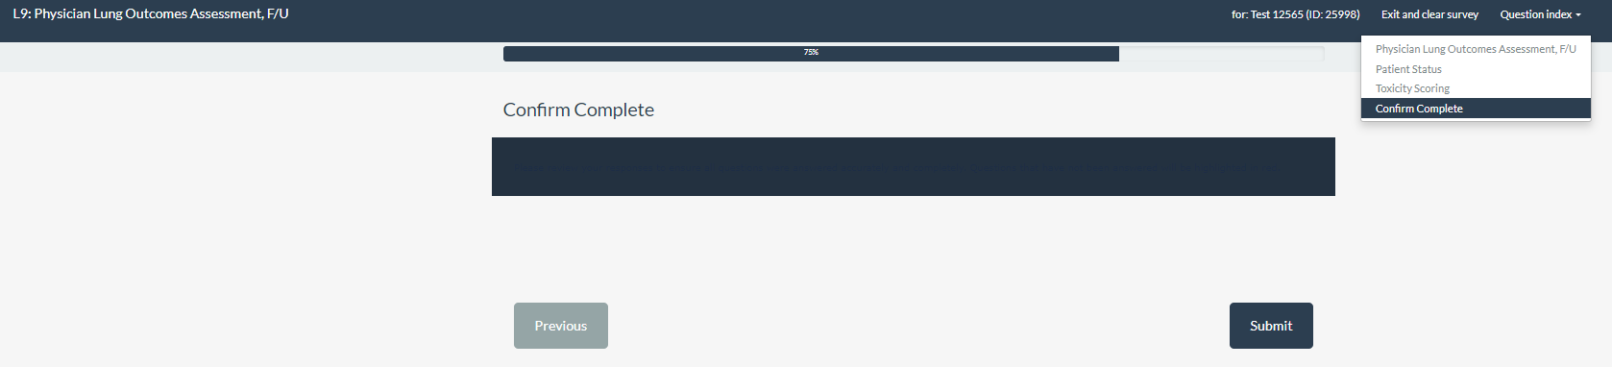
- To save a form, submit must be selected at the end of each form. Forms that are not submitted will show as not completed. Data marked as not completed will not be included in site reports and other data sets.
“N” indicates not submitted. To submit the survey, select take survey. Verify saved data and submit survey.

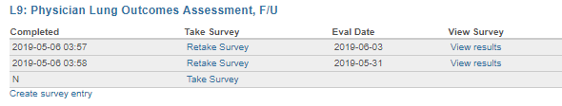
For repeating forms-to submit a new survey for the same patient, select create survey entry. Verify saved data and submit survey.

Review & edit submitted data

- To review submitted data, select view results on the desired form. Responses to each question are displayed in table format. Results cannot be edited in this view.
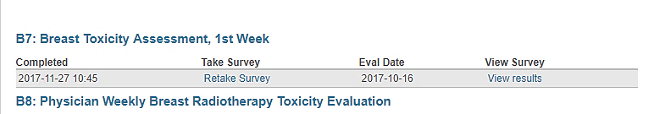
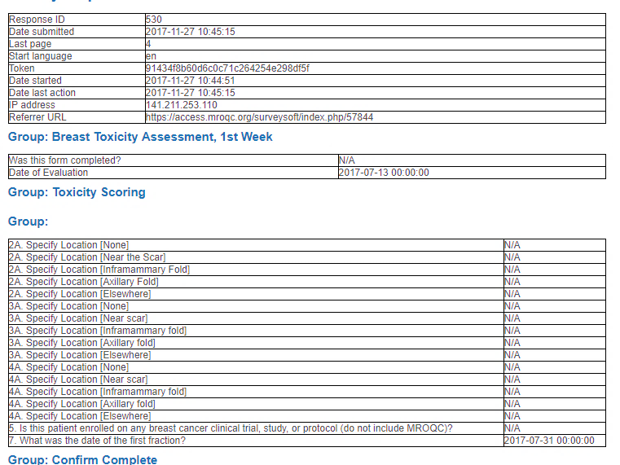
- To edit submitted data, select retake survey. The survey will reopen allowing edits to be made to any question. To save changes, the form must be resubmitted. The completion date will update to reflect the new submission date

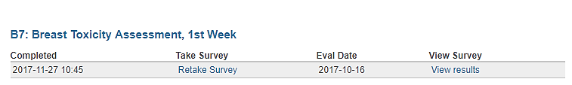

Most current submission date

Patient decides to no longer complete surveys

If a patient no longer wishes to complete surveys, you may change their survey status on the enrollment page. CDA and physician surveys should still be collected and entered.
- To change a patient’s survey status, go to the homepage and enter the patient’s MROQC ID number or their hospital ID number in the search bar.
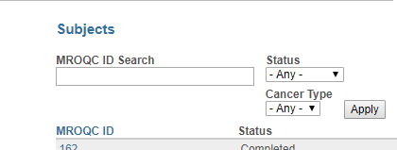

- Select the edit tab at the top of the page to open the enrollment form (SE1). Scroll down to the bottom of the page to the did subject refuse to complete surveys field and change the response to “yes.”
- In the ChangeLog Message box, enter the reason for the change (see example message below).
- Select save. The patient’s status should not be changed to “completed.”

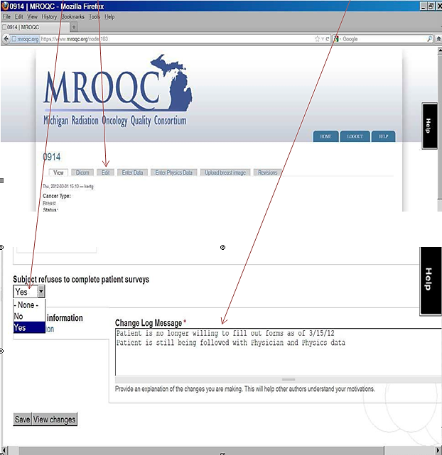

Survey not completed by patient or physician

To track when a patient or provider does not complete a survey, the survey should be entered, and the reason for not completing the survey should be selected. By doing so, missing information is properly accounted for. If the patient has decided to stop treatment or to not return for follow-up appointments, the termination form should be entered instead of entering missed forms.
- Create a survey for the missed form and reply no to the question “was this form completed by the patient/physician?”
- Once no is selected, select the reason why the survey was completed. Other may be selected if the reason is not listed. No Answer is not an appropriate response.
- The evaluation date should be the date of the scheduled appointment.
- Submit and save the form.

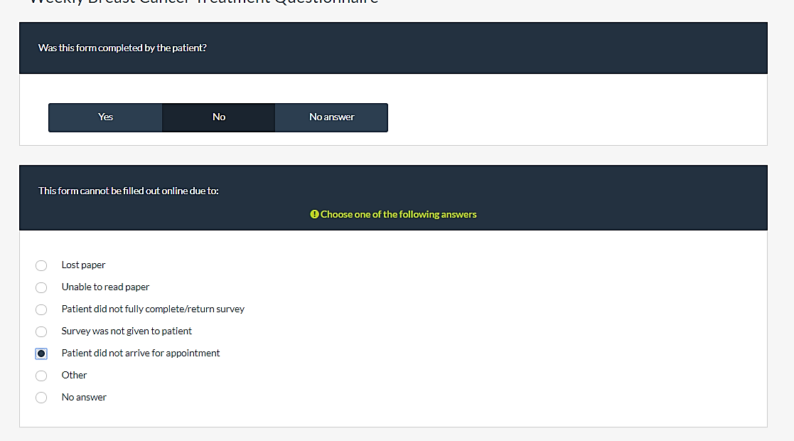

Excluding Forms:
If an extra copy of the form has been created in error or for any other reasons, it can be excluded by following these steps:
- Select ‘Yes” for the question “Do you want to exclude this form”
- Select ‘Yes” for the question “Are you sure you want to exclude this form”
- Document the reason why the form is being excluded

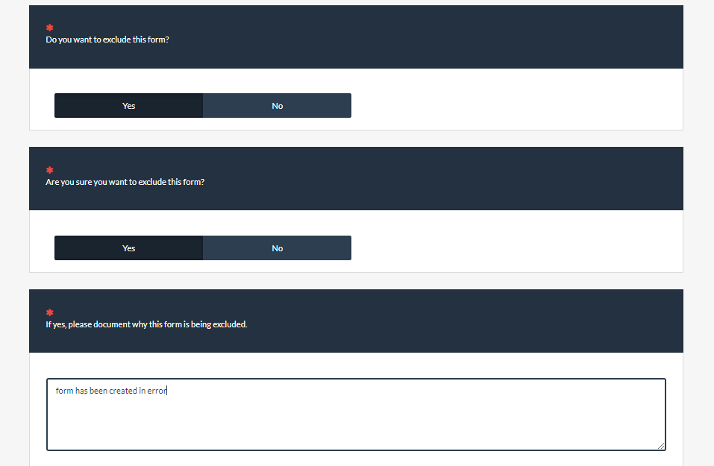
Please document the reason why the form is being excluded. Verify saved data and submit survey.

Patient has completed treatment and f/u

When a patient completes treatment, follow-up, and all clinical forms and physics information has been entered; the patient’s status should be changed to completed. Once the patient’s status has been changed to complete, they will no longer show on the homepage unless the status box is changed to completed. To change a patient’s status complete the following steps:
- Select the appropriate patient
- Click the edit tab at the top of the page
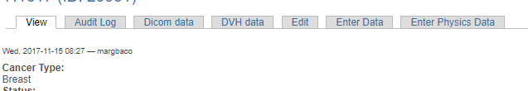
- On the enrollment page, change the patient’s status to completed and click save.
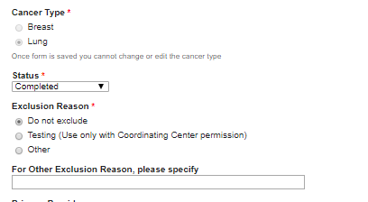

Changing/Editing forms when patient’s status is “Complete”:

Once the patient’s status has been changed to complete, they will no longer show on the homepage unless the status box is changed to active. The following steps show us how to pull a record up and change the patient’s status:

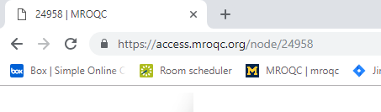
1. In the URL, add node/the pts MROQC ID (see pic below). Then press enter. The patient's record will come up.
Enter MROQC ID

2. From the patient's main page select the "edit " tab
Click Edit tab

3. Next change the patient's status back to active and enter the form changes. After you enter the forms, change the status back to completed.

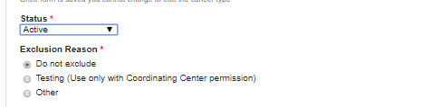
Change Status

Terminating a patient (SE2 Form)

If a patient does not complete treatment or does not return for follow-up appointments, an early termination form (SE2) must be submitted, and the patient’s status should be changed to completed. Before submitting an SE2 form, ensure all required forms as stated on the top of the termination form has been submitted.
- Under SE2: Early termination of MROQC patient participation, select create survey entry
- The date of early termination should be the date of the patient’s last appointment or their date of death.
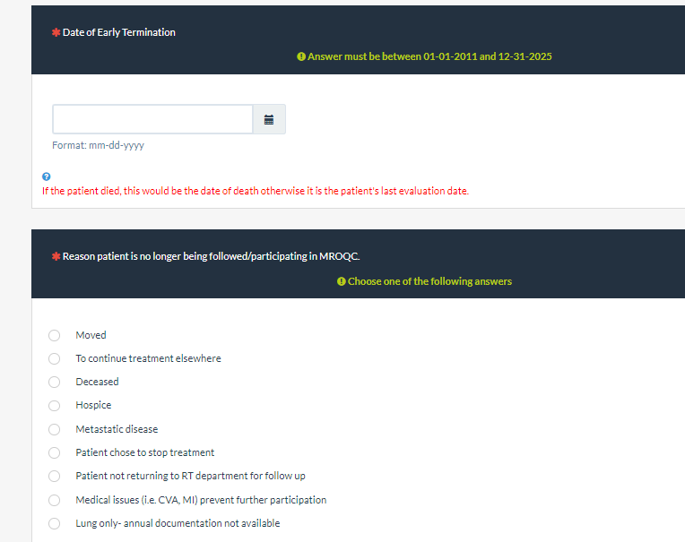
- The reason should be selected that best explains why the patient is no longer participating in MROQC.

- Once the form is submitted, change the patient’s status to completed on the enrollment page.

